Sprint 4 Plan

Circular Barter & Gift

Release 1.0

Completion Date: 2/28

Revision Number: 1

Scrum Master: Michael

**Sprint Goal**: Finish MVP, add locations for each post, simplify the image upload API.

**Tasks**

*User Story 1: (3) As an item poster, I want to be able to delete a post because I no longer want to trade an item.* ***Must***

* Tasks
  + 1a When a post is deleted update both the listings and offers tables in the backend (2)
  + 1b Add a delete button (1)

User Story 2: *(6) As someone who had made an offer, I want to be able to communicate and agree to an exchange with them without giving my phone number or email away.* ***Must***

* Tasks
  + 2a Create a messaging interface (1)
  + 2b Store messages in the backend (3)
  + 2c Send and fetch messages (3)

*User Story 3: (3) As someone who posted an item listing, I want to be notified within the website when I get a trade offer for an item.* ***Could***

* Tasks
  + 3a Augment the offers table with a variable that it tracks whether the user has seen it (1)
  + 3b Have new offers propagate the notifications tray (2)

*User Story 4: (2) As someone interested in an item listed, I’d like to make an offer to exchange it for something I have.* ***Must***

* Tasks
  + 4a Create a view to see all offers you have made as a user (1)
  + 4b Create a list view to see all offers for a particular listing (1)

*User Story 5: (3) As a listing poster, I want to advertise my item with an exchange location so that others can see where I want to make the trade.*

* Tasks
  + 5a Adding a location field to the listing creation form (1)
  + 5b Add a field to the database (1)
  + 5c Convert from address to coordinates (1)

*User Story 6: (2) As someone who wants to pick up an advertised item, I want to see the exchange location on a map embedded in a listing page.*

* Tasks
  + 6a Embed a Google Map into each listing page centered on the user specified coordinates (2)

*User Story 7: (4) As an item or offer poster, I want to be able to upload an image from my device directly to the app.*

* Tasks
  + 7a Update listing an offer creation forms to accommodate the new image uploading feature (1)
  + 7b Hook into Imgur API to upload user’s image and get the link to it. (3)

**Team Roles**

* Ian (Product Owner, UI Designer)
* Kenneth (developer, full stack)
* Gonzalo (developer, full stack)
* Hengtian (developer, frontend)
* Micheal (Scrum Master, backend)
* Daniel (developer)

**Initial Task Assignment**

* Ian: 2a, 7a, 7b
* Kenneth: 1a, 1b, 4a, 4b
* Gonzalo: 5a, 5b, 5c
* Hengtian: 6a
* Micheal: 2a, 2b, 2c
* Daniel: 3a, 3b

Infrastructure Tasks:

Spikes

* Learn how to integrate imgur upload for seamless image uploading
* Learn how to use Google maps API to input and display location data

**Initial burnup chart**

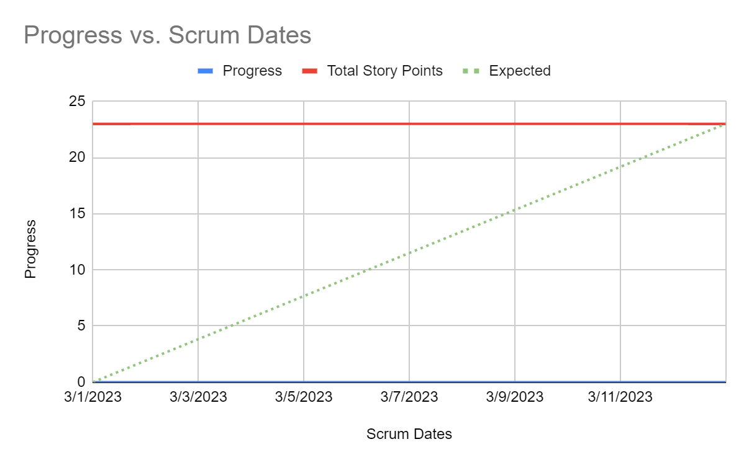

[**Initial Scrum Board**](https://trello.com/invite/b/gx6MgIyB/ATTI05a8695a17ffdbae9ebdfa6643b1ffb3EFEE51C2/tasks)

**Scrum Times:**

9:05 - 9:20 MWF